Blood Bank Inventory & Donor Matcher.

Title:-
Blood Bank Inventory & Donor Matcher ,
A Step-by-Step Procedural to Structured Java Implementation in project.

Abstract:-
In emergency medical situations, finding a compatible blood donor quickly can be a matter of life or death. Hospitals and blood banks often struggle with managing their current inventory levels and manually cross-matching compatible blood types when an urgent request comes in. This project solves that problem by building a Blood Bank Inventory & Donor Matcher System in Java.
The project was built step-by-step over a six-week period, with each phase introducing a core programming concept to solve a specific part of the problem. We started with basic variables to track initial blood stock volumes, added a command-line interface using Scanner to register new donors, used conditional statements to screen donors for medical eligibility based on age and weight, and implemented loop menus to keep the system running continuously. Finally, we organized the code cleanly using modular methods and used parallel arrays to manage and look up the blood stock levels for all major blood groups during patient matching.
The resulting application acts as a working prototype for a digital blood bank, showing how fundamental software building blocks can be combined to automate inventory tracking and enforce medical compatibility rules.

Advantages:-
Automated Screening & Error Reduction: The digital system automatically checks rules for donor age and weight. This completely removes the risk of human error or oversight during manual entry.
Instant Compatibility Tracking: By building a computerized cross-matching matrix using arrays, the system links patients to safe, matching blood types instantly during emergencies.
Saves Development Memory: Instead of using separate independent variables for every single data entry, the program uses indexed parallel arrays to keep all active files clean and organized within a single localized storage frame.
Persistent User Interface: Using a continuous control loop keeps the execution window open. Users can perform multiple tasks back-to-back without restarting the application each time.
Modular Code Reuse: Breaking down functions into structured methods prevents repetitive code blocks, making it very easy to fix bugs or update logic later.

Implementation of java.

Module-1

Week-1:-Problem to program.
Concept: Utilizing diverse primitive datatypes (int, double, char, String) and using the Scanner class to read real-time user inputs.
Program Objective: Program Objective: Initialize basic blood group stock counts directly inside variables to form the core foundation of our inventory.

CODE:-
public class Module1_Week1 {
public static void main(String[] args) {
System.out.println("--- Blood Bank Inventory Init ---");

int stockA_Positive = 15;
int stockB_Positive = 8;
int stockO_Negative = 3;

int totalUnits = stockA_Positive + stockB_Positive + stockO_Negative;

System.out.println("A+ Units: " + stockA_Positive);
System.out.println("B+ Units: " + stockB_Positive);
System.out.println("O- Units: " + stockO_Negative);
System.out.println("Total Initial Stock in Bank: " + totalUnits);
} }

Output evidence:-

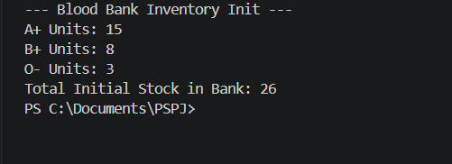

Week-2:-Data types & Intake shell.
Concept: Utilizing diverse primitive datatypes (int, double, char, String) and using the Scanner class to read real-time user inputs.
Program Objective: Build an intake shell to dynamically register a single emergency donor from the keyboard console.

CODE:-
import java.util.Scanner;
public class Module1_Week2 {
public static void main(String[] args) {
Scanner scanner = new Scanner(System.in);
System.out.println("=== Emergency Donor Registration Intake Shell ===");

System.out.print("Enter Donor Full Name : ");
String donorName = scanner.nextLine();

System.out.print("Enter Blood Type : ");
String bloodType = scanner.next();

System.out.print("Enter Donor Age : ");
int age = scanner.nextInt();

System.out.print("Enter Weight in kg : ");
double weight = scanner.nextDouble();

System.out.println("\n--- Intake Verification Summary ---");
System.out.println("Donor registered: " + donorName);
System.out.println("Blood Group: " + bloodType);
System.out.println("Age: " + age + " years old");
System.out.println("Weight: " + weight + " kg");

scanner.close();
}
}

Output Evidence:-

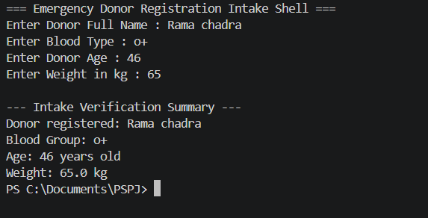

Module-2

Week-3:- Selection Statements.
Concept: Implementing conditional flows using if, else, nested if, and multi-branch execution using switch, break, and default.
Program Objective: Validate if a donor is medically fit to donate based on nested conditions (age/weight) and display blood compatibility rules using a switch panel.

CODE:-
import java.util.Scanner;

public class Module2_Week3 {
public static void main(String[] args) {
Scanner scanner = new Scanner(System.in);
System.out.println("=== Medical Eligibility & Compatibility Dashboard ===");

System.out.print("Enter Donor Age: ");
int age = scanner.nextInt();

if (age >= 18) {
if (age <= 65) {
System.out.print("Enter Weight (kg): ");
double weight = scanner.nextDouble();

if (weight >= 50.0) {
System.out.println(" Status: Medically Approved for Donation.");
} else {
System.out.println(" Status: Rejected. Weight must be at least 50kg.");
}
} else {
System.out.println(" Status: Rejected. Age exceeds maximum limit of 65.");
}
} else {
System.out.println(" Status: Rejected. Donor must be an adult (18+).");
}

System.out.print("\nEnter Patient Blood Type to check compatibility rules: ");
String bType = scanner.next().toUpperCase();

System.out.print("Compatible donors for " + bType + ": ");
switch (bType) {
case "O-":
System.out.println("Only O- (Universal Donor standard).");
break;
case "O+":
System.out.println("O+, O-");
break;
case "A+":
System.out.println("A+, A-, O+, O-");
break;
case "AB+":
System.out.println("Universal Recipient (Can accept all blood types: A, B, AB, O)");
break;
default:
System.out.println("Other standard types (B+, B-, A-, AB- match based on antibody checks).");
break;
}
scanner.close();
}
}

Output Evidence:-
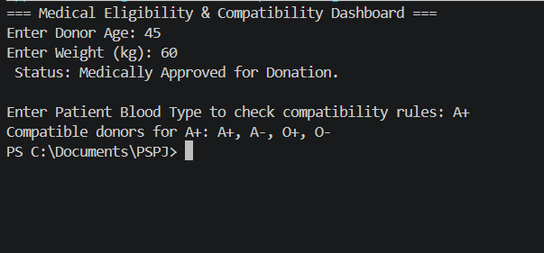

Week-4:-Iteration Control Structures(Loops).
Concept: Utilizing looping constructs (while, do-while, for) alongside branching operators (break, continue) to keep an application persistent.
Program Objective: Create a continuous operational hub terminal menu using a looping pattern, giving users an interface that remains open until they choose to exit.

CODE:-

import java.util.Scanner;

public class Module2_Week4 {
public static void main(String[] args) {
Scanner scanner = new Scanner(System.in);
int option;
do {
System.out.println("--- MAIN BLOOD SYSTEM CONTROL PANEL ---");
System.out.println("1. Register Live Donation");
System.out.println("2. Simulate Emergency Matching Cycle");
System.out.println("3. Run Diagnostics Loop");
System.out.println("4. Shut Down Terminal Interface");
System.out.print("Select Menu Reference Action (1-4): ");
option = scanner.nextInt();
if (option == 4) {
System.out.println("Safely closing inventory interfaces. Goodbye!");
break;
}
switch (option) {
case 1:
System.out.println("[Action Log]: Executing Donor Registration System Routine...");
break;
case 2:
System.out.println("[Action Log]: Initializing Cross-Match Matrix Systems...");
break;
case 3:
System.out.println("[Action Log]: Running structural countdown loops...");

for (int i = 3; i > 0; i--) {
if (i == 2) {
System.out.println(" Testing branch bypass (continue state)...");
continue;
}
System.out.println(" Diagnostic Pulse Check " + i + " OK.");
}
break;
default:
System.out.println(" Unrecognized action index. Select alternative.");
}
} while (option != 4);

scanner.close();
}
}

Output Evidence:-
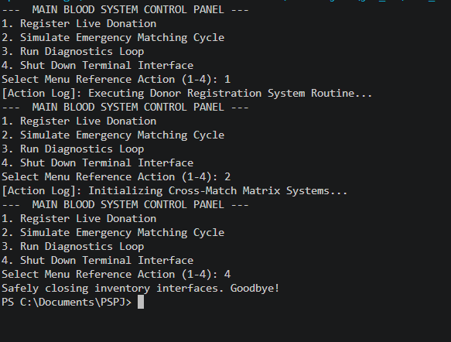

Module-3

Week-5:- Methods and Recursion.
Concept: Organizing code blocks into highly re-usable functional methods and using Recursion (a function calling itself) to perform continuous data processing.
Program Objective: Build standard helper methods to execute inventory subtraction and deploy a recursive tracking routine that calculates projected unit volumes over time.

CODE:-
public class Module3_Week5 {

public static int deductBloodUnits(int currentStock, int requestedUnits) {
if (requestedUnits > currentStock) {
System.out.println(" Alert: Insufficient inventory. Transaction denied.");
return currentStock;
}
System.out.println("Allocation Authorized. Dispatching units...");
return currentStock - requestedUnits;
}
public static int simulateEmergencySupplyCascade(int unitsAtRisk, int depthCount) {
if (depthCount <= 1) {
return unitsAtRisk;
}
return unitsAtRisk + simulateEmergencySupplyCascade(unitsAtRisk / 2, depthCount - 1);
}
public static void main(String[] args) {
System.out.println("=== Testing Modular Functional Layouts ===");

int stockLevel = 25;
stockLevel = deductBloodUnits(stockLevel, 7);
System.out.println("Updated Inventory Level: " + stockLevel + " units.");

System.out.println("--- Recursive Blood Redistribution Projections ---");
int totalCascadeProjection = simulateEmergencySupplyCascade(10, 3);
System.out.println("Recursive System Multi-Tier Allocation Projection: " + totalCascadeProjection + " total bags.");
}
}

Output Evidence:-

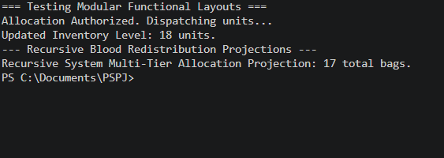

Week-6:- Comprehensive Array Structures.
Concept: Using indexed collection blocks (Arrays) to manage multiple data items simultaneously.
Program Objective: This final program incorporates all concepts from Week 1 to Week 6 into a single, fully functional system. It uses coordinated array maps to store the inventory volumes and structural strings for all standard blood groups.

CODE:-
import java.util.Scanner;
public class Module3_Week6 {
private static String[] bloodGroups = {"A+", "A-", "B+", "B-", "AB+", "AB-", "O+", "O-"};
private static int[] stockLevels = {12, 5, 8, 3, 4, 2, 20, 6};
public static String[] findCompatibleDonors(String target) {
switch (target) {
case "O+": return new String[]{"O+", "O-"};
case "O-": return new String[]{"O-"};
case "A+": return new String[]{"A+", "A-", "O+", "O-"};
case "A-": return new String[]{"A-", "O-"};
case "B+": return new String[]{"B+", "B-", "O+", "O-"};
case "B-": return new String[]{"B-", "O-"};
case "AB+": return new String[]{"A+", "A-", "B+", "B-", "AB+", "AB-", "O+", "O-"};
case "AB-": return new String[]{"A-", "B-", "AB-", "O-"};
default: return new String[]{};
}
} public static void main(String[] args) {
Scanner scanner = new Scanner(System.in);
int commandInput;
do {
System.out.println("=======================================================");
System.out.println(" FULLY COMPILED BLOOD BANK INVENTORY & DONOR SYSTEM ");
System.out.println("=======================================================");
System.out.println("1. Display Current Stock Inventory (Arrays)");
System.out.println("2. Patient Request & Compatibility Matcher (Selection)");
System.out.println("3. Run Recursive Allocation Math (Recursion)");
System.out.println("4. Exit Application System Terminal");
System.out.print("Provide system command option (1-4): ");
commandInput = scanner.nextInt();
switch (commandInput) {
case 1:
System.out.println("\n[LIVE INVENTORY LEDGER]");
for (int i = 0; i < bloodGroups.length; i++) {
System.out.println("🔹 Group Type [" + bloodGroups[i] + "] : " + stockLevels[i] + " bags in stock.");
}
break;
case 2:
System.out.print("\nEnter Patient Blood Group Required: ");
String requestedGroup = scanner.next().toUpperCase();
String[] matches = findCompatibleDonors(requestedGroup);

if (matches.length == 0) {
System.out.println(" Entry Error: Not a globally verified blood category type.");
break;
}
System.out.println("\n Scanning matching stock options for " + requestedGroup + ":");
for (String matchedType : matches) {
for (int i = 0; i < bloodGroups.length; i++) {
if (bloodGroups[i].equals(matchedType)) {
System.out.println(" -> Available Compatible Stock: Type " + bloodGroups[i] + " = " + stockLevels[i] + " units.");
}
}
}
break;

case 3:
System.out.println("[RECURSIVE SYSTEM CALCULATION]");
System.out.print("Enter current backup blood units to test cascade: ");
int initialUnits = scanner.nextInt();

int result = Module3_Week5.simulateEmergencySupplyCascade(initialUnits, 3);
System.out.println("Total projected cascading emergency stock holding: " + result + " units.");
break;
case 4:
System.out.println("Terminating operational memory matrices. Shutdown completed smoothly.");

break;
default:
System.out.println(" Input execution error. Retrying command cycle."); }
} while (commandInput != 4);
scanner.close();
}

}

Output Evidence:-
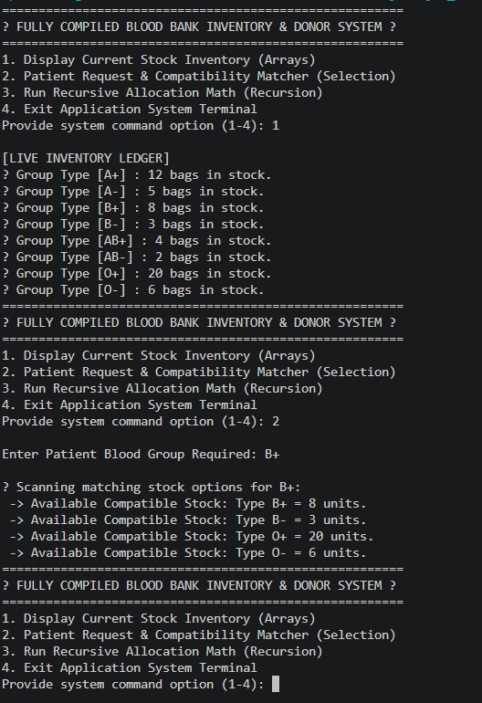

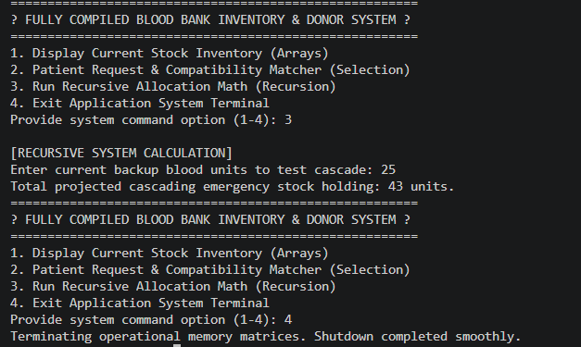

Conclusion :-
In conclusion, this project shows how a real-world medical problem can be solved step-by-step using basic Java programming. Over the 6-week development period, we successfully combined simple variables, user inputs, smart eligibility filters, and continuous loop menus into a single working system.
By using methods and arrays, the program handles data efficiently, speeds up the blood matching process, and avoids common mistakes. Overall, this project creates a strong foundation that can easily be expanded in the future with a proper database or a visual application window.

